Once you sign up for a telehealth, Virtual Visit, you will receive something that looks like the message below. You will need to click the link that says “Join Microsoft Teams Meeting”.
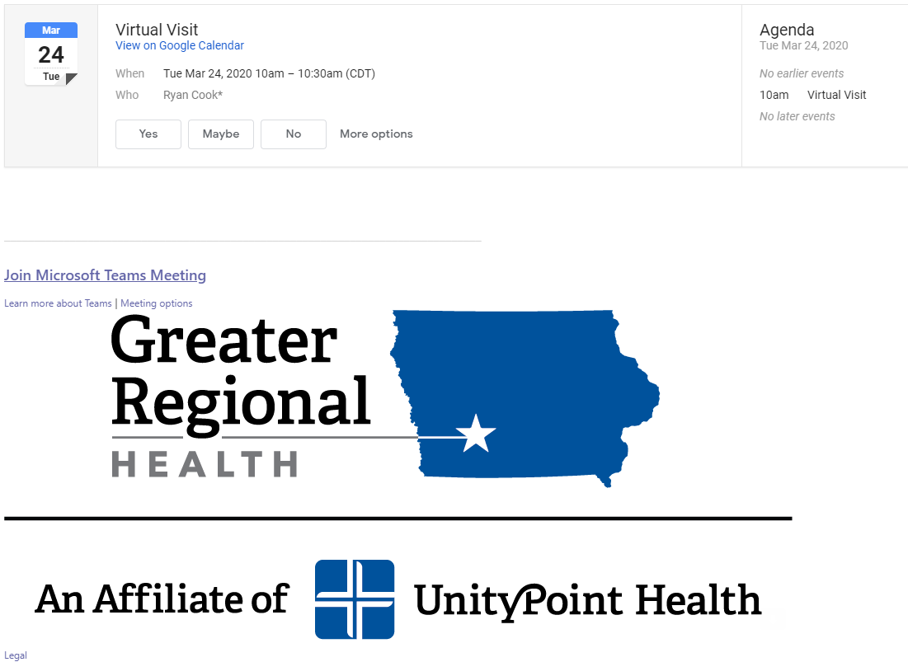

You will be redirected to a new website. Click on “Join on the web instead”.
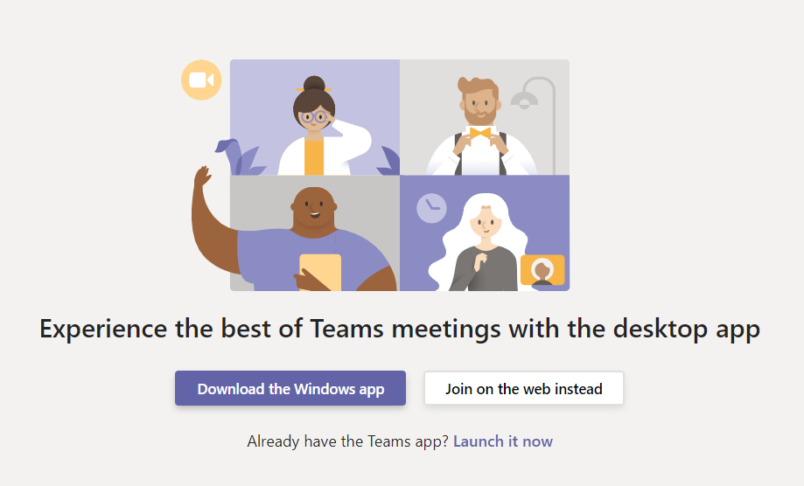

Microsoft Teams will need access to both your camera and microphone for your provider to see and hear you. When prompted, hit OK or Allow for Teams to Access Microphone or Camera. Next it should ask for your name. Please enter your first name as shown below.
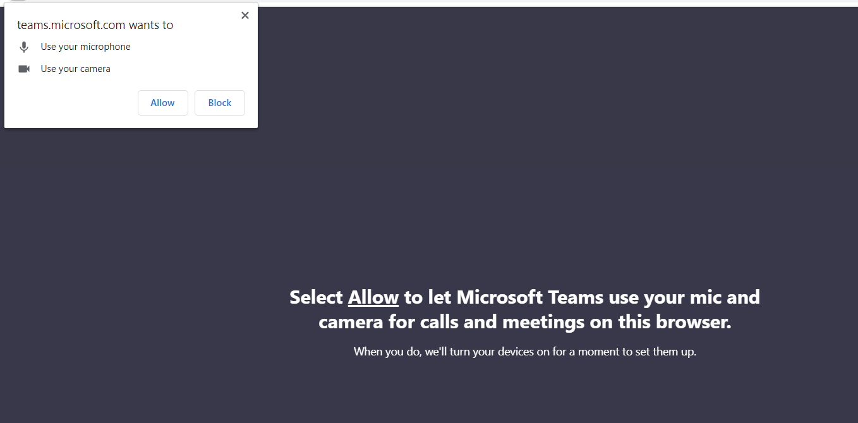

Next it should ask for your name. Please enter your first name as shown below.
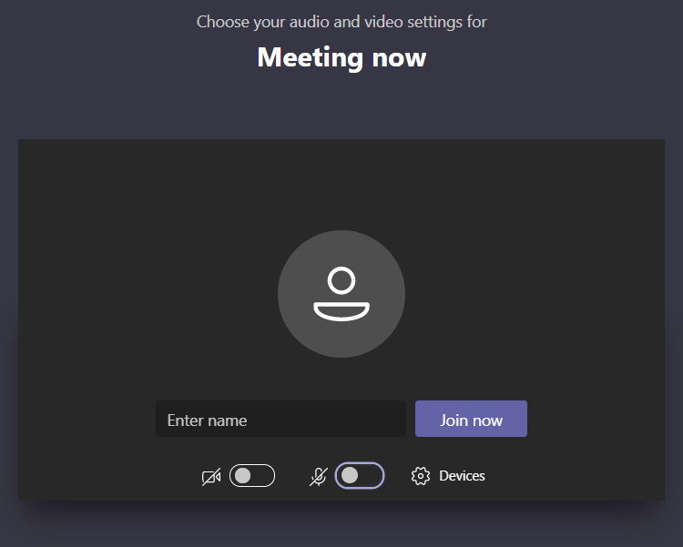

Once you have entered your name, you will see the screen below. Please wait here for a nurse to start the conversation.
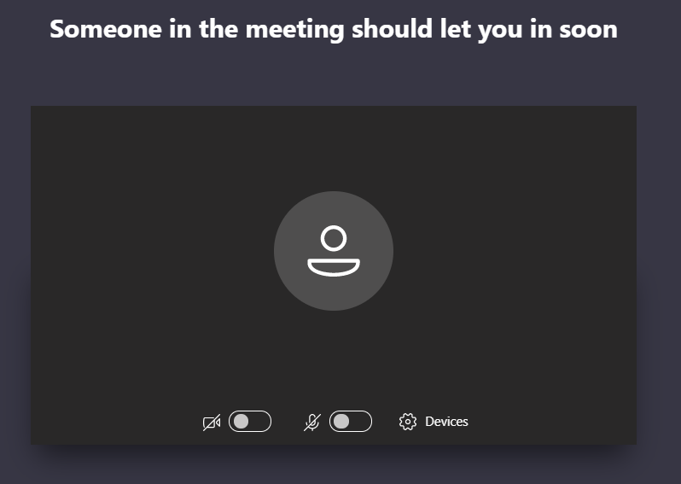

You may need to push a button on the bottom of your screen to turn on your camera and/or turn on your microphone. You will also need to use the red button to end the call once your visit is over. The picture below explains which buttons you may need to use.
Turn Camera On/Off

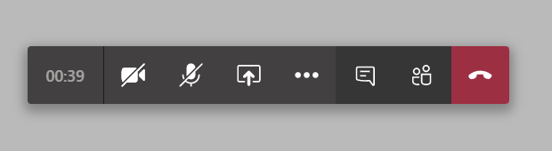
End Visit
Turn Microphone On/Off

