Once you sign up for a telehealth, Virtual Visit, you will receive something that looks like the message below. You will need to click the link that says “Join Microsoft Teams Meeting”.
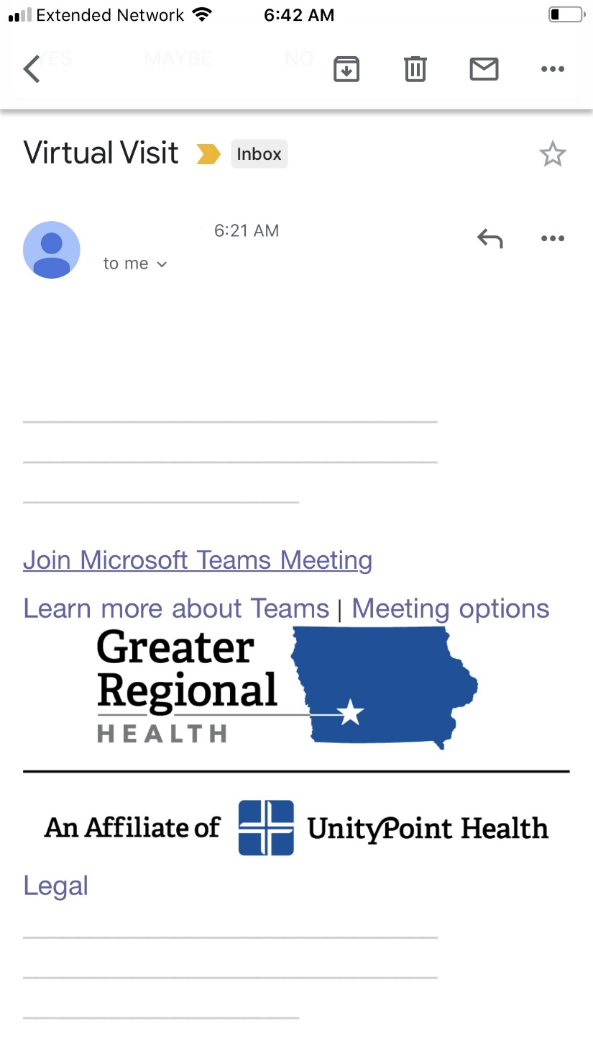

There will be a pop up asking you to open with another application if you do not have Microsoft Teams installed already. It will look like below.
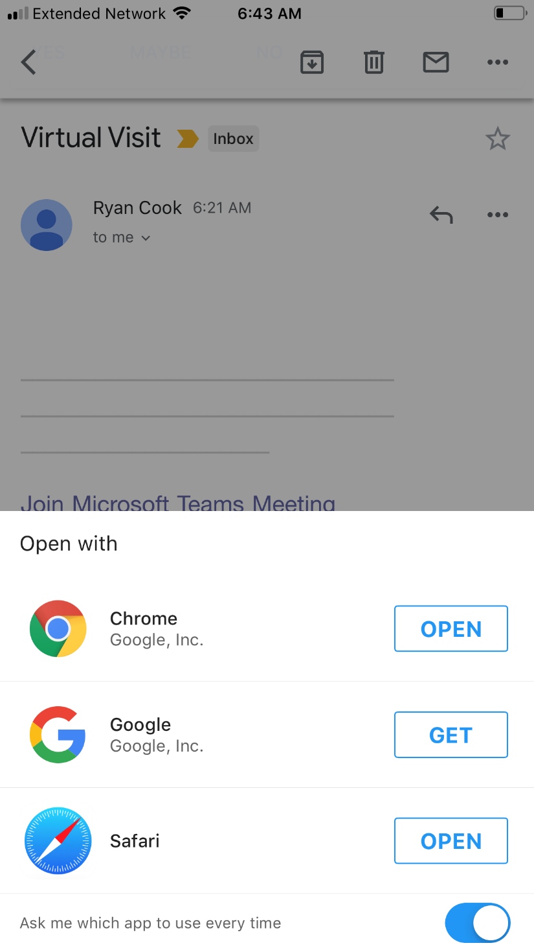

If you do not have Microsoft Teams installed, you will be taken to another webpage that will direct you to the appropriate store to download Microsoft Teams. This is a free application. Once you have Microsoft Teams installed, you may have to go back to your email and click on the link again, as mentioned in the first step. Once you are in Microsoft Teams you will see the image below. Click “Join as a guest”.
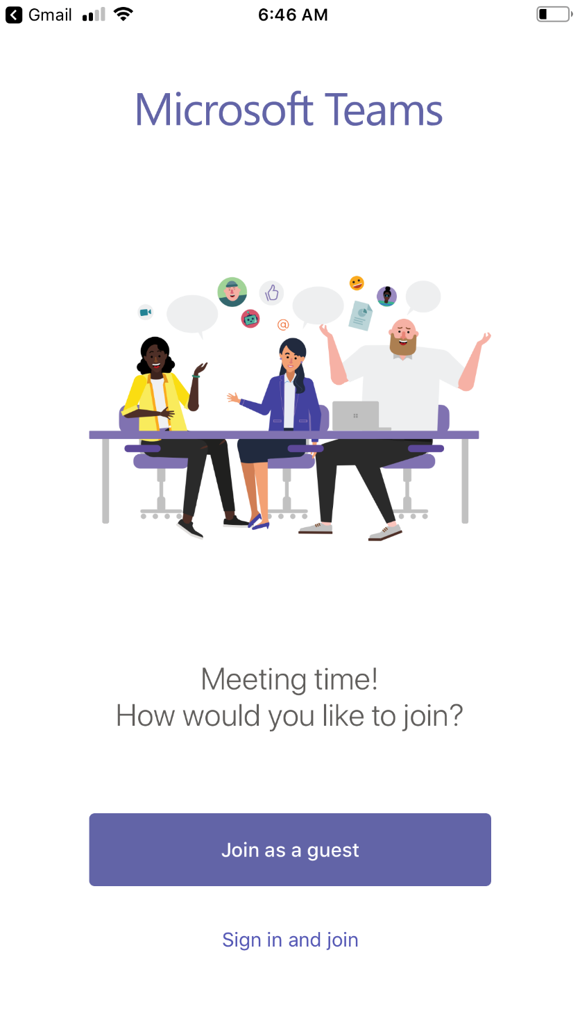

Microsoft Teams will need access to both your camera and microphone for your provider to see and hear you. When prompted, hit OK or Allow for Teams to Access Microphone or Camera. Next it should ask for your name. Please enter your first name as shown below.
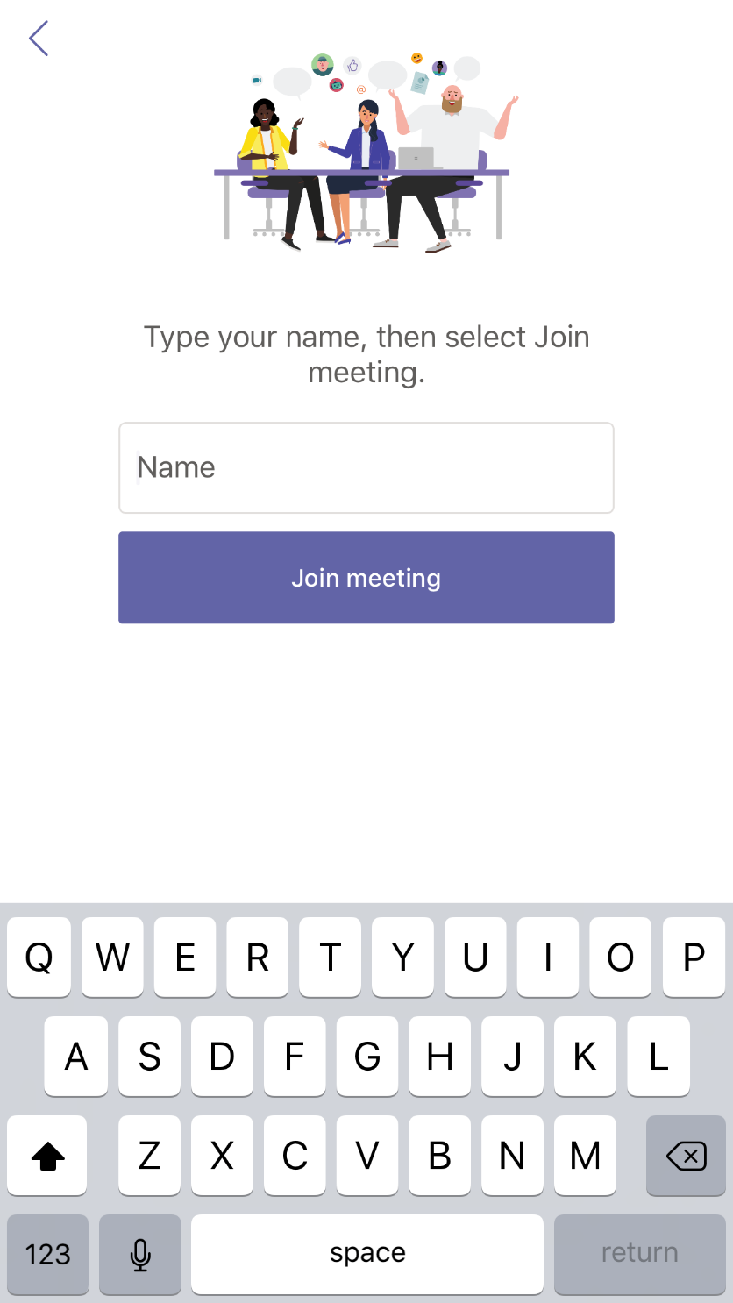

Once you have entered your name, you will see the screen below. Please wait here for a nurse to start the conversation.
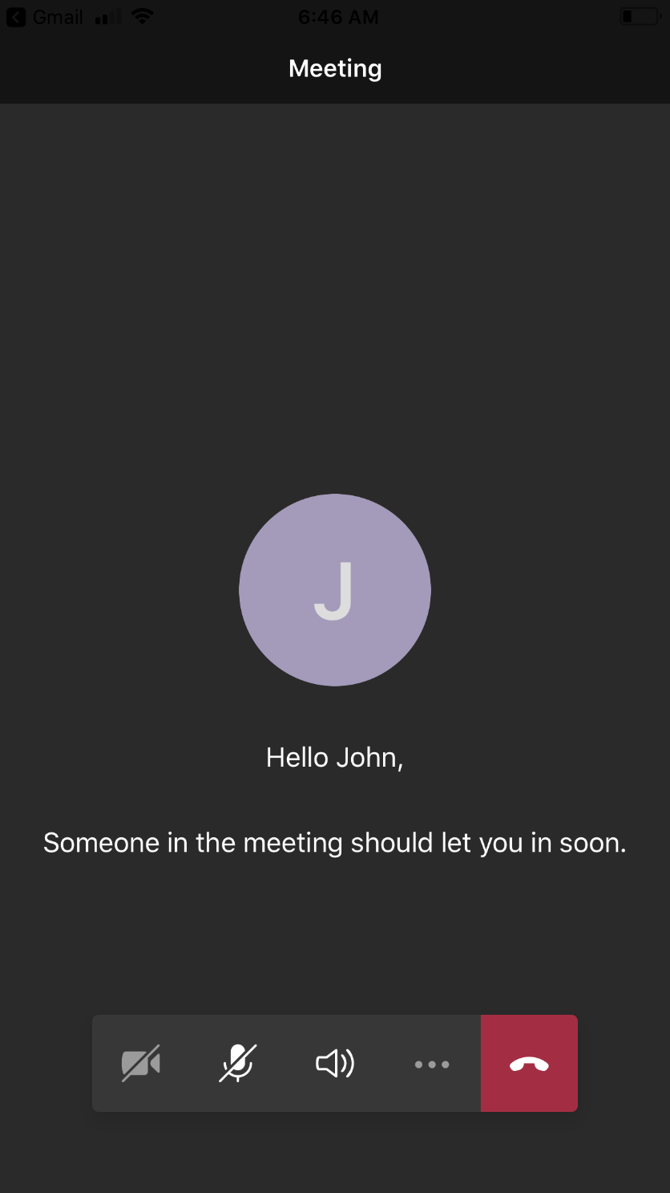

You may need to push a button on the bottom of your screen to turn on your camera and/or turn on your microphone. You will also need to use the red button to end the call once your visit is over. The picture below explains which buttons you may need to use.
Turn Camera On/Off
Turn Microphone On/Off
End Visit

